Sprint 0 Report

Angelo Goro

# Key Decisions of the SOS Project

• Object-oriented programming language: C++

• GUI library: Qt

• IDE: VS Code

• xUnit framework: GoogleTest

• Programming style guide: Google C++ style guide

• Project hosting site: Github

# 2. Unit testing (Tic Tac Toe program)

(1) Program execution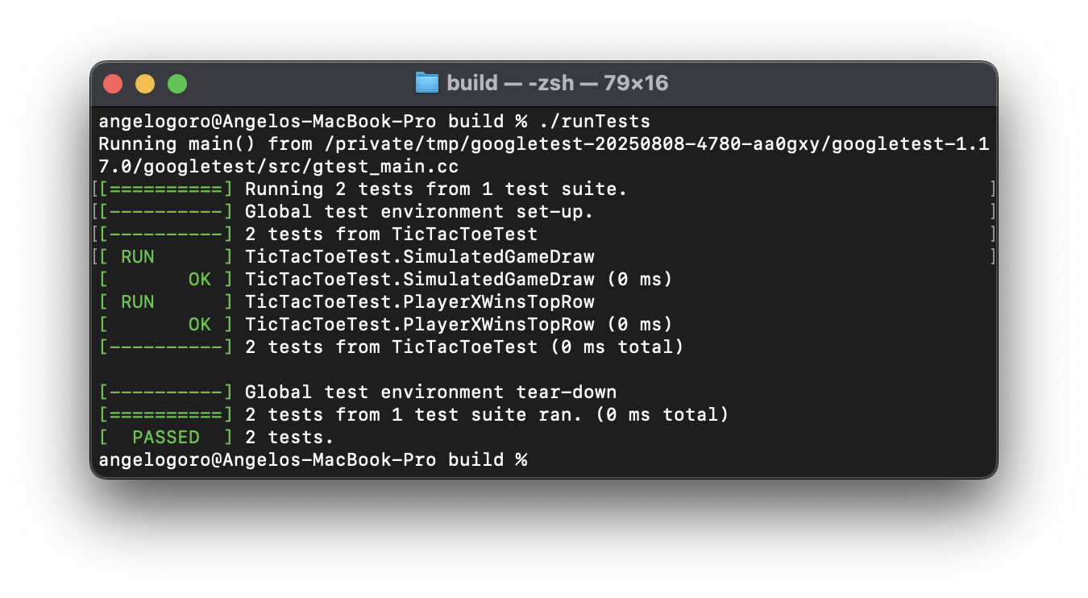

(2) Source code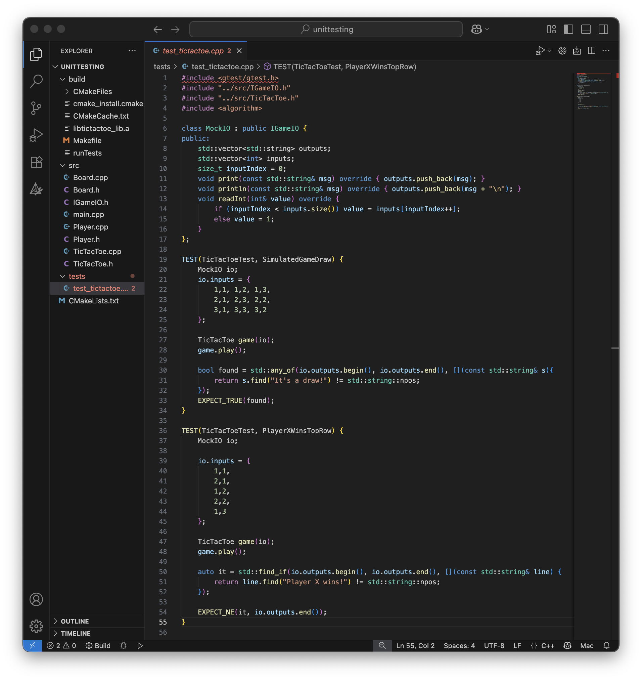

# 3. GUI programming

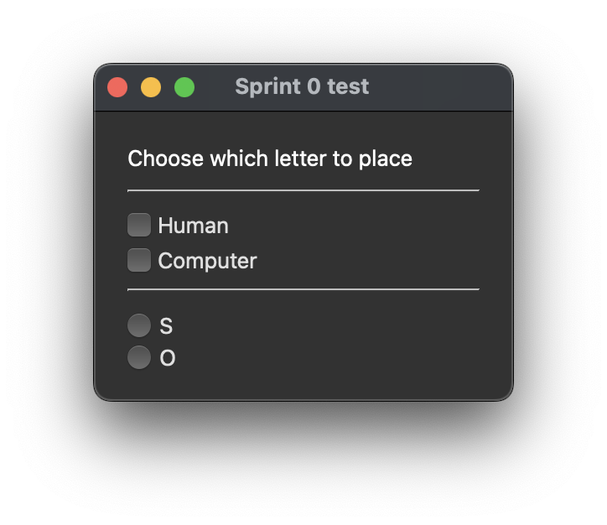

(1) GUI program execution

(2) GUI source code